SUBMIT BY
April 4, 2025
DELAWARE AVIATION
HALL OF FAME
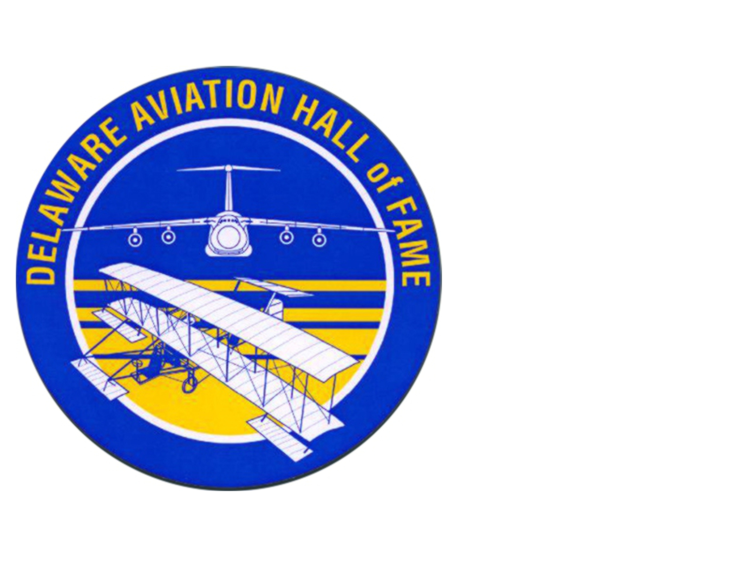

INDUCTEE NOMINATION FORM

NOMINEE Information (WHO YOU ARE NOMINATING)
Name:
Address: |  |  | E-mail:
Phone: |  | Cell Phone: | Fax:
City: |  | State: | ZIP Code:

NOMINATOR Information (WHO YOU ARE)
Name:
Address: |  |  | E-mail:
Phone: |  | Cell Phone: | Fax:
City: |  | State: | ZIP Code:

Relative or other appropriate contact IF THIS IS A POSTHUMUS NOMINATION
Name:
Address: |  |  | E-mail:
Phone: |  | Cell Phone: | Fax:
City: |  | State: | ZIP Code:
Relationship to Nominee:

Reason for nomination

(DESCRIBE IN DETAIL WHY THEY SHOULD BE INDUCTED)

CUT AND PASTE YOUR RESPONSE HERE IF REPLYING ELECTRONICALLY

IF REPLYING BY POSTAL SERVICE ATTACH YOUR RESPONSE TO THE FORM
WHAT IS THEIR CONNECTION TO DELAWARE?

CUT AND PASTE YOUR RESPONSE HERE IF REPLYING ELECTRONICALLY

IF REPLYING BY POSTAL SERVICE ATTACH YOUR RESPONSE TO THE FORM
A HEAD AND SHOULDERS PHOTO OF THE INDUCTEE WILL BE REQUIRED IF CHOSEN
ARE THERE COPIES OF CONFIRMING DOCUMENTS?
(NO ORIGINALS PLEASE)
(DD214, Medals, Awards, Letters of Commendation, etc.)
(Documents may be vetted)

INDICATE YOUR RESPONSE HERE IF REPLYING ELECTRONICALLY

IF REPLYING BY POSTAL SERVICE CIRCLE YOUR RESPONSE ON THE FORM
YES (ATTACHED) | YES (NOT ATTACHED, WILL FORWARD LATER) |  |  | NO

IF REPLYING BY POST SEND TO:

DELAWARE AVIATION HALL OF FAME
PO Box 4303
Greenville, DE 19807

IF REPLYING ELECTRONICALLY SEND TO:

Info@DAHF.org

